**Accounting for extra inertia/weight**

**Known:**

$$m=310 kg$$

$$a=7.4 m/s^{2}$$

$$v_{max}=30.5 m/s$$

**Solving and graphing:**

Speed, Torque, Power

**Solving for:**

Full Car, Wheel, Motor

**Full Car**

$$F=ma=310*7.4=2294$$

$$T=F*L=2294*0.207=474.858 Nm$$

$$P=F*v_{max}=2294*30.5=69.967 kw$$

**Speed graph**

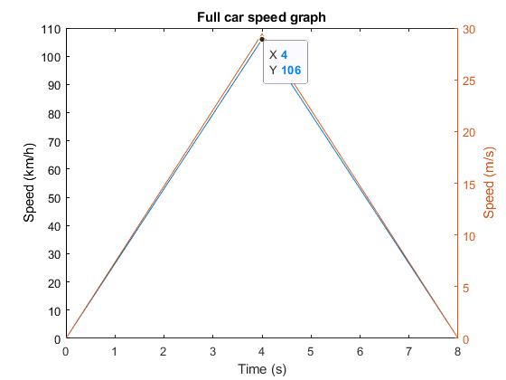

**Torque graph**

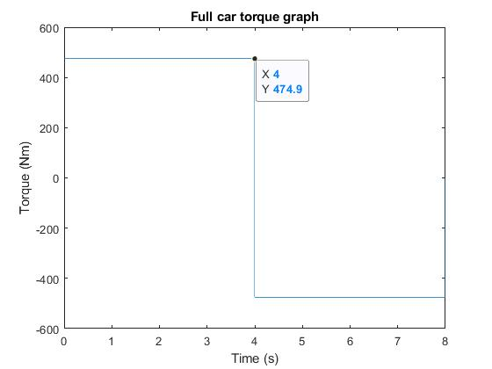

**Power graph**

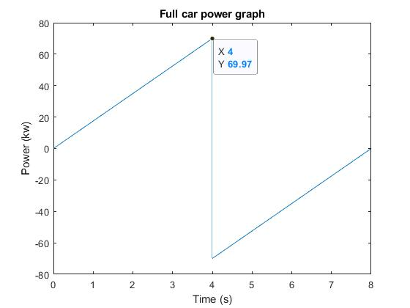

**Wheel**

$F=2294$ Does not changes

$$T=\frac{T_{Car}}{4}=\frac{474.86}{4}=118.715 Nm$$

$$P=\frac{P_{Car}}{4}=\frac{69.967}{4}=17.491 kw$$

**Torque graph**

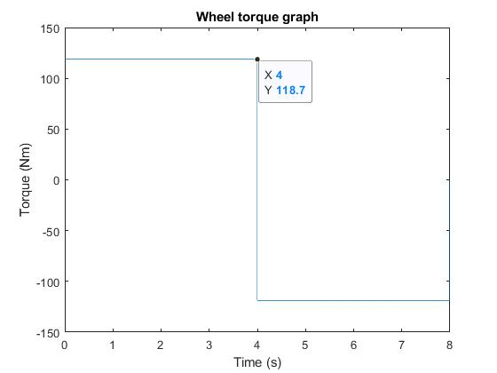

**Power graph**

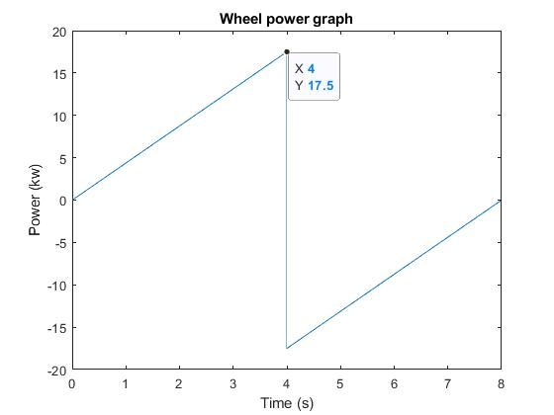

**Motor**

$$Gearbox ratio=Gr=4.5$$

$F=2294$ Does not changes

$P=P_{Wheel}=17.5 kw$ The power does not change (Assume perfect system)

From the datasheet. For the given power, torque is $T=626.9 Nm$, $T=118.71*4.5=534.217 Nm$

**Speed graph**

@ 6000 RPM (maximum), speed of the motor = 102.14

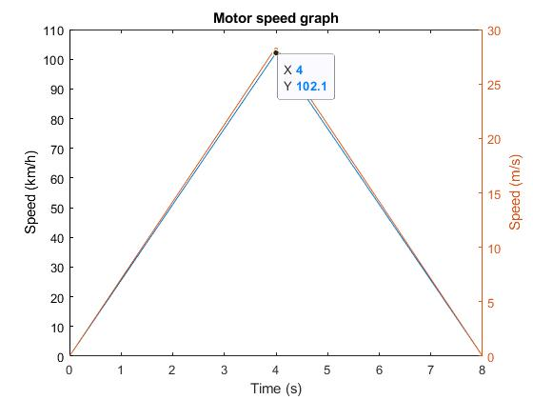

**Torque graph**

Torque value from datasheet

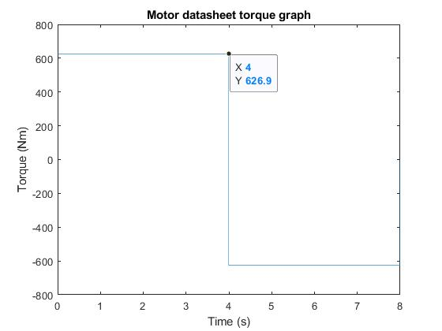

Torque value from calculations

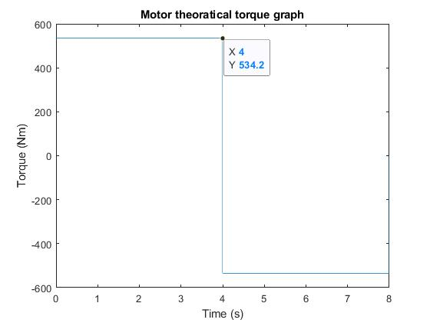

**Power graph**

